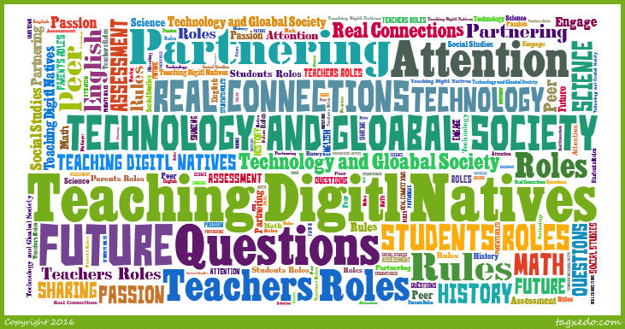

This Wiki Contains Summaries about the book, Teaching Digital Natives.

Introduction

What's different?

Today’s students are different, in fact the world is a totally different place than it was when we as adults were growing up. Technology is a part of our every aspect of daily life. Over half of the world’s population have a cell phone and computers are being created that are not visible to the naked eye. The differences can also be seen inside the classroom, students bring in their own devices and complete research through unlimited amounts of technological resources. Students are learning Robotics first hand and most importantly, students are learning informally. This means, the informal research that students complete on their mobile devices and computers at home on their personal passions and interest are helping them to become experts in those fields without them even realizing.

It’s quite common to hear that students today in modern society have attention deficit disorders, i.e. (ADD or ADHD); but this is not the case. These students possess the ability to sit and play video games, watch movies, and manipulate cellular devices for hours on end; so there is definitely not an issue with short attention spans or them having the ability to concentrate. However what has changed or is the underlying issue when it comes to students lacking attention and concentration skills are the student’s tolerance and needs. Students have altered their interests to focus only on what interests them and on things that treat them as individuals rather than as a group or class. The world is a crowded place, more so than it was a few decades ago; so it’s important to differentiate, personalize, and individualize instruction. Also, their way of thinking has changed. Everything is based on technology and because their thinking is so advanced, some feel that school is not necessary and drop out. As teachers, we are lacking in catering to their needs of the way that they are learning.

Student’s attention spans are not any shorter; but they are shorter for our old ways of learning.

- They do not want to lectured to.
- They desire respect, trust, and their opinions to be valued and counted.
- They want to follow their own interests and passions.
- They want to create, using tools of their time.
- They want to collaborate with peers on group work and projects.
- They want to make decisions and share control
- They want to connect with their peers, share opinions in class as well as around the world.
- They want to cooperate and compete with their peers.
- They want an education that is not just relevant, but real

These expectations are not selfish or unrealistic. Bottom line: Students learn differently than in the past. Meaningful learning is of great importance. These students are learning based on “their world” that is to come; so as an educator we need to prepare them for the 21st Century and teach them to respect the past and learn from it hence “Partnering Pedagogies”.

Real, Not Just Relevant

Students know that they can, and want to, learn things in the classroom that they can take and use in the real world. In today's education educators to work on making lessons real for the students by using real life examples. Making things real in the classroom helps students understand the importance of the knowledge. More on how to make things real and not just relevant is discussed in chapter 4.

How to motivate learning?
Some teachers motivate and engage students in the 21st Century is done by integrating technology into the curriculum. Teachers that are concerned actively request more training and professional development to effectively incorporate the technological component for their student’s needs; because it is their responsibility to coach and guide the use of technology for effective learning. The key aspect in motivating and engaging students is through passion; but to identify each student’s passion the teacher must get to know the child. A child’s passion is the key to learning anything regardless if the child already understands the passion for it or not. Once the passion has been identified, a learning path can be provided for each student that is maximally beneficial and it can enable each student to achieve and go as far as possible; which is the true goal as an educator.

How to Ignite Passion in Your Students: 8 Ways Educators Can Foster Passion-based Learning

Preparing For Change
The best way to help students learn is to prepare them to learn at a pace that ultimately matches the pace of the rapidly changing world. It’s important to respect the past; but if learning is not focused on the future and the future is not getting equal time in our education, we are setting are students up for failure. The problem is we don’t know enough about the future; but we do know enough about the past to “partner” our way of teaching. To accomplish a better way of learning for today’s students we must make learning meaningful, relevant, and present it in a way that prepares them to deal with rapid, chaotic change that may sometimes even be dangerous.
Teaching and the Arts necessary for 21st Century Learning

Chapter 1

How does one teach for long-term, tomorrow, and still teach about the past?
Partnering
Partnering happens when the students are the researchers and inventors using new tools while the teachers are there to give assistance by asking questions, guiding, giving background information, and assessing the students.

Moving Ahead
It is important for teachers to move away from direct instruction where teachers lecture while students listen, take notes and memorize. Today's students are not engaged in this type of instruction. If the students are not listening, what is the point of giving a lecture?

What are ways that are working to keep students engaged? Making connections to the outside world. Making connections allow students to see the relevance and importance to what they are learning. One way to make this connection is by field trips. Can't go on field trips? Take your students on virtual field trips! Another way to keep today's students engaged is by allowing them to have a voice. Students can have a voice by participating group work and discussions. This also allows students to hear the thoughts and ideas of their classmates.

How should students be viewed? Today's kids are intellectually growing much faster than in the past. What kids learn and the age they learn them has changed. Our curriculum and material are no longer "age appropriate". Today's kids are being raised in a world where thinking outside the box is critical. Because this way of thinking is becoming popular it is hard for educators to have full control over a child's learning. With the resources kids have today, they have the potential to accomplish what has never been accomplished. Because students today have the potential to do great things they need to be provided with information and resources that will benefit them in the future. This means some of the methods from the past may not benefit the students today. They need to learn how to best use the resources they have to enhance their knowledge. Learning independence is very important for one to succeed. Students need to learn how to self-monitor, self-assess and self-correct as much as possible. They also need to learn how to create, learn, program, adopt, adapt and relate to everything they encounter. So what does this mean for the educators? Educators need to raise their expectations.

How Partnering Works

From Telling to Partnering

The students and teachers need to focus on the parts of the learning process they are best at.

The students should:

- Find and follow their passion
- Use the resources available
- Research and gather information
- Answer questions and share their thoughts and opinions
- Practice
- Create presentations in text and multimedia

The teachers should:

- Create and ask questions
- Guide students
- Put material in context
- Explain one-on-one
- Create rigor
- Ensure quality

When using partnering, how does the curriculum get covered? The students are learning the same information, if not more, they just like to take the active role in finding out information rather than being told the information. Lecturing is not the only way to present certain material. Here is a suggestion to transform your direct instruction to the partnering method, take the facts you would present and turn them into questions the students could explore.

The partnering process is not new to education. There are various types of learning methods that have the similar techniques. The name partnering is just relatively new. Prensky just prefers the word partnering because it shows everyone has a different but equal role.

The same curricula can be covered using partnering as was covered using traditional methods. The material never changes just the pedagogy.

Technology's role in partnering is to help students personalize his or her learning process. This way students can somewhat learn at their own pace but primarily so they can learn the ways they prefer. It allows the teacher to assist the students individually. One important thing that educators need to know is that adding technology without changes the pedagogy will not be beneficial. Partnering pedagogy is the best way to add technology because it allows the students to be fully involved with what they learn.

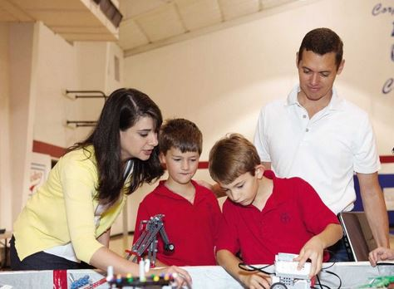

Establishing Roles and Mutual Respect

"We are all learners, we are all teachers"

A key element of teaching is respect. Without respect learning partnering is not effective. Teachers and students must know and accept that they both have equal importance to contribute to the learning process. To be able to accept the fact that both students and teachers contribute equally one needs to know the roles they each play.

The students are:

- the researchers
- the technology users and experts
- the thinker and sense-maker
- the world-changer
- the self-teacher

The teacher is:

- the coach and guide
- the goal setter and questioner
- the learning designer
- the context provider
- the rigor provider and quality assurer

Students today like learning from their peers. This is partly because "they speak the same language". They have similar experiences with each other than with a teacher. Peer-to-peer teaching and learning is a good type of partnering. Students tend to like it when they are able to teach the class, to them it is another way to show that a teacher respects their thoughts. Peer-to-peer is a great way to help close academic and technology gaps. Sometimes having children work together is more beneficial than having them work alone.

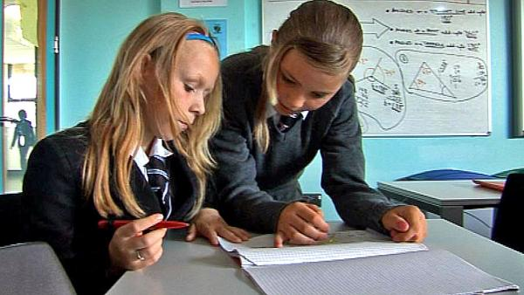

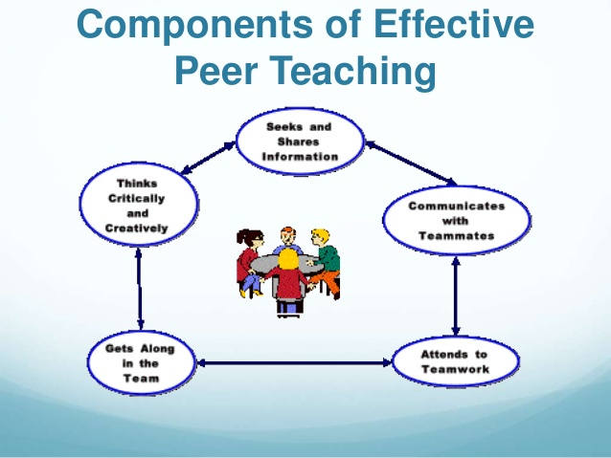
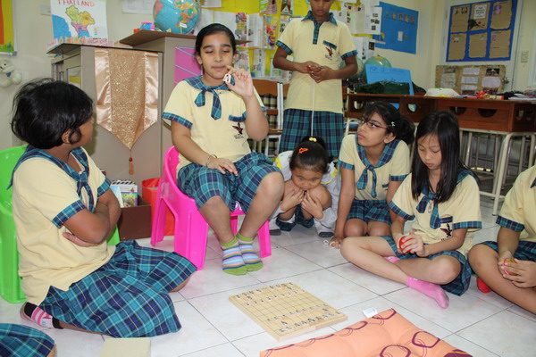

Teachers and administrators must work together for partnering pedagogy to work. Administrators need to understand and accept this approach. They must support their teachers during the transition from traditional to partnering. This support can be encouragement, evaluating and/or assisting. Assistance can be given by pair teachers together or offer professional development. *When offering professional development it is import to make sure the focus is not just about using various technologies but about how to change the way your present information.

Parents need to have some involvement with partnering as well. They need to fully understand the partnering process. Parents need to know how this new way of learning benefits their child in the long run. They need to know that these changes are being made from the bottom to the top (pre-k to college/employers). It is also important to ask parents to encourage their children and praise their creative accomplishments, in and out of school. In order for parents to have this type of involvement, they first need to know how to build a good relationship with their child's teacher(s).

Chapter 2 div></div>

Partnering can help you become more of a tutor or guide for your students and gives you more time to differentiate instruction and meet individual students needs and passions.

Time to Partner?

Ask yourself these questions about your students:

- Do your students often seem bored and restless?
- Do they have trouble paying attention when you are talking?
- Are they often active in distracting ways?
- Are they doing less well than you would like?

If the answers are yes, then your students are ready to have a more active, challenging approach to learning.This transition will have them become more independent learners.

Ask yourself these questions to see if you are ready?

- Do I think of my students as partners with different skill sets and do I talk to them directly about how they want to learn?
- Do I know each of my students' passions, and can I use these to facilitate their learning?
- Do I see alternatives to lecturing , telling, and explaining to all? Am I ready to "leave the stage"?
- Do I know what level of partnering is appropriate for my students and me?
- Do I make learning real and not just relevant?
- Do I know how to translate content into guiding questions?
- Do I understand learning and technology in terms of verbs and nouns?

Hopefully, you can do these things asked above, and if you can hopefully you can learn how.

Seeing students differently

In order for partnering to work teachers must see their students as partnering in the learning process. Treating students with respect and trust important in partnering. The teachers are to give less direction and more guidance and expect students to change their behavior as a result. It is the students' job to accept and live up to the challenges they are given by the teachers. This will require more hands-on doing, more independent thinking, and more creating from the students.

Teachers need to "leave the stage" in other words it is time for them to do less telling. Even teachers that have transformed their classroom into a partnering setting have a hard time with telling less. Although teachers should tell less it does not mean they have less to say. They are just not in the front of the room lecturing instead they are asking questions, moderating discussions with students, offering an opinion as part of that discussion, and giving students feedback on projects. Teachers need to have an understanding of the difference between talking and telling.

The way a classroom is set up has a major influence on how well the partnering pedagogy works. The most common type of set up is a theater or auditorium setup, where the desk is in rows facing the front of the class. This type of setup is designed for direct instruction, not partnering. The arrangement of the desk and should change according to the needs of different activities. There are many ways one can set up their classroom. One example is the horseshoe shape. This is a great way to set up the classroom if your students have computers. If you have the students face the wall and their screens you are able to see what is on your students' screens. This is a good way for teachers to be able which students might need some additional guidance. When you need to have a discussion you can have the students turn the chairs so they can see one another as well as prevent their computers from being a distraction. Another arrangement is having the teachers desk in the middle of the room with desk arranged around the teacher individually or in groups. Another setup option is having the desk in small groups to facilitate team interaction. You can also put desk/chairs in a circle for class discussion. A mixed setup is a variety of configurations throughout the classroom. The image below has the example of the tradition setup and examples for partnering style setup.

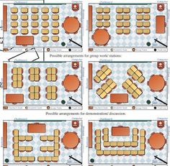

When deciding what setup will work best for your class, ask your students how they would have to arrange the class.

Choosing your partnering level

There is not a one-size-fits-all partnering that covers all students and all situations. So how does one know what partnering will most benefit their classroom? There are three levels of partnering one can try. These steps are basic partnering, guided partnering, and advanced partnering. When trying any of these levels it is import to make sure students have a say in planning, doing, and evaluating. It is also import for the students to know what they are supposed to do and have instructions provided in some way. The main difference between these three levels is the amount of guidance or scaffolding given as well as the breadth of the guiding questions.

Basic Partnering is a good level for teachers to start with. The teacher gives students guiding questions and lets them work on their own, individually or in groups, to answer them. The students can use whatever tools they have available. Teachers can provide some guidance about appropriate tools to use and decisions to make. This is often called inquiry-based learning. This type of partnering requires the students to be self-directed.

Providing Variety

The kids will become just as board with basic partnering as they do with direct instruction if the teachers do not design interesting variations of basic partnering. Examples of Variations:
- Virtually including in groups students who are physically in other locations or classes, based on the topics, areas, or languages that are being studied.
- Students need to use various methods and tools to find answers.
- Approaching topics through whole-class games or simulations.
- Have students design real solutions to real problems
- Going outside the classroom (physically or virtually) whenever possible.

Sharing Results

In basic partnering students can share their results to the class and teacher using methods and tools of their choosing. Keeping the presentations short and brief are encouraged. Being able to create short but informative presentations is a using skill to have. While the students are working it is important to have discussions about the guided questions and the steps they are using to find results.

Guided Partnering is good for students that need more assistance when working on assignments. The difference in basic partnering and guided partnering is that how the students work to find answers to the guided questions is far more structured. The type of presentations the students give are more structured as well. This type of partnering is practiced by many teachers who do project-based or inquiry-based learning with students considered to be as risk.
*** http://www.teachingmatters.org/ is a great resource for partnering projects.

Advanced Partnering is for the teachers and students who are ready to move away from textbook ordered curriculum toward longer and more complex learning projects. One difference between advance partnering and the other two partnering levels is that they are typically longer-term units in which a large number of curricular standards are integrated and learned through the solving an overarching problem or case. These types of problems or cases are often considered more true-to-life learning. This type of partnering is used in medical and business school. Students and teachers participating in problem-based learning are able to deal with more complex issues and problems, make real-life type decisions and do so in a real-world time frame.

Other Types of Advanced Partnering
- Process-oriented guided inquiry learning (POGIL)
- Challenge-based learning
- Technology-enhanced active learning (TEAL)
- Quest-based learning

Technology and Partnering

Digital technology is a large part of partnering pedagogy in the 21st century, no matter the level of technology used.

According to Prensky's text there are two important questions to address:

1. How do you partner using whatever types of technology are (and are not) available in your school and classroom?

2. How do you prevent technology from taking over the essentials that you are trying to teach?

The best way to approach these questions is to think in terms of verbs and nouns. Verbs are the skills that students need to learn, master, and practice. They do not change with time. Nouns are the tools the students use to learn, practice, or master the verbs. There are traditional tools such as books and more 21st century tools such as the Internet. The nouns change frequently.

Example: Prezi is a tool (noun) used for presenting (verb).

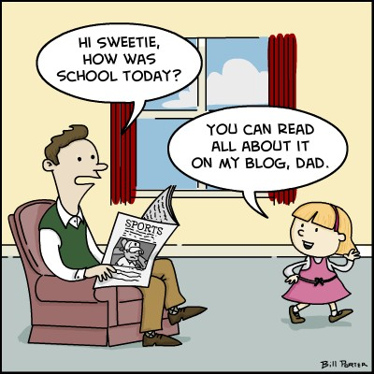

Begin with the verbs!

In order to avoid letting technology take over the classroom, the teacher should begin with the verbs (skills). In doing this the focus goes to the skills that students need to be proficient in, skills that teachers and employers want students to know. Focusing on the verbs also helps teachers to answer the dreaded question, "why do I need to know this?" Students will be learning and practicing skills that they will currently use and that will be needed in the future.

"There are nearly 50 learning verbs that we use and want students to master, and over 100 nouns available to students to use in their efforts."

Teachers should choose the appropriate verbs to be learned, evaluate the group os students they are working with, and then blend the verbs with the content and technology being used. Choosing a verb will depend on what will be most useful to the students and the different things being taught. Once the verb is choosen, the students should choose the noun based on what is available to them.

Partnering and the Required Curriculum

Partnering can be used with the required curriculum that all teachers must follow. No matter the pedagogy used, the questions that the students should be able to answer remain the same. As do the skills they need to master. The only thing that changes is the method in which they learn the information. In partnering, students begin with the questions and discover the answers for themselves, with assistance from their peers and teachers. The guiding questions paired with the focus on the verbs is what makes the connection between partnering pedagogy and the curriculum.

Guiding questions + Verbs = Connections

Connections provide specific learning goals for students. Students have an easier time achieving these goals when they are clearly presented. Students are also able to reach the set goals in their own way.

Ensuring Connections Get Made
Not all students are able to make the connections on their own, therefore it is up to the teacher to point out those connections. This is the final job of the partnering teacher: REVIEW. This is the time to go over what was learned from the initial question, to discuss the quality of the answers given, and to provide feedback to the students.

The Student's Role in Connecting the Partnering Pedagogy and Content

1. Students should view themselves as "partnering professionals". As someone who is able to discover the important questions in any subject they are studying.

2. Students need to view themselves as individuals, capable of discovering the answers to the important questions in their own unique
way, creating work they are proud of.

3. Students should be aware of verbs in which they are learning with the task they are doing. They need to work to improve upon those skills in order to develop a wide range of skills.

Taking Your First (or Next) Steps into Partnering

Essentially Partnering is creating a new relationship between the teacher and the students. It's important to create a relationship where the students feel like equals in the partnering process. In order to do this, teachers should begin by talking to the students about what you are trying to do and why. To make this transition successful teachers should talk with other teachers who have made the transition, visit classrooms, watch videos, and do research.
Start Slowly

It can be tempting to jump right into partnering, but it is best to ease in slowly. Pensky gives an example of starting with a partnering project, such as: "How can we improve our school?" or "How can we improve our school?" or "How can we improve our community?" This can be done as a school district project, or just between one or two classes. Students will use the basic guiding questions, verbs, and then review the answers as a class. There are other examples of how to get started such as the Teaching Matters, or others from PBL books and websites. The important thing is once you begin, do not give up!

Overcome Other Barriers

The hardest part about beginning this style of teaching is leaving the "stage". If the technology is not available, use what you have. If the students aren't showing responsibility, begin with smaller steps. If administration or parents aren't on board, just do it a little at a time until they can see the benefits and changes taking place. Always remember that good partnering begins and ends with talking with students, both individually and in large groups.

Chapter 3

Chapter three discusses the importance of learning about student’s individual passions and interests and how to incorporate those into the classroom. Prensky discusses today’s students and how they are a different type of student to teach compared to those of the past. Today’s students expect their individual needs to be met and have a low tolerance for anything that is not meeting those needs.

Differentiated instruction is a word that is being heard more frequently in the teaching field. It has become the only way to approach learning in order to engage and motivate students. The way this works is by learning each individual student’s passions or the things that really interest them and incorporating it into learning.

All students have a passion or main interest, even if they don’t realize it yet. It is important that teachers take the time to learn what these interests are. These interests are the route in which partnering teachers can make individualized learning happen. When students are interested in what they are learning or can see how a topic relates to their passion, the information sticks with them better. The information becomes relatable. This in turn makes the students want to learn more. In order to find student’s passions, the teacher just needs to ask.

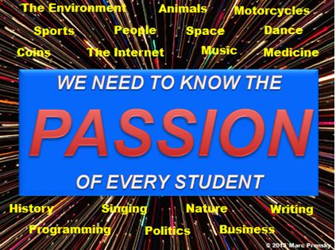

Prensky took a poll of how many teachers and administrators knew the passion of their students. The results were as followed:

- a quarter said less than 10%
- more than half said less than 20 percent
- more than three quarters said less than 40 percent
- Only two people polled answered over 70 percent
- no one answered over 90 percent.

The teachers polled began to realize why their students were uninterested in learning.

"I spend a great deal of energy putting my own passion into my teaching. It didn't occur to me that each of my students has his or her own passion as well. Now I understand why, sometimes, when I say a particular thing, certain heads will suddenly perk up."

Most students know what their passion is, but some might need help finding what interests them the most. It’s important to be supportive if they have not yet discovered their passion, but to also let them know how crucial it is to find this out. In order for students to become interested, they must know what it is they are interested in. They need to know who they really are before the teacher is able to discover who they are. This will allow for the teacher to motivate learning and to encourage students to do things they might not otherwise do.

Prensky says that “students usually report to me that they are bored in 50-100 percent of their classes, 50-100 percent of the time.”

In order to change this teachers must think about students differently and individually. Every student is different, learns differently, has good days and bad days, and as long as the work is getting done, teachers need to respect that. Another way the student’s individual passions can fuel learning in the classroom is by bringing diversity into all the student’s learning. Learning from students is yet another way for teachers to connect their student’s passions to the process. Technology is a great example. Often times the students are more technologically savvy and can actually teach the teacher a thing or two. By allowing students to share what they know builds confidence, fuels their passion, and frees up time for the teacher to focus on other needs.

Iteration in the classroom means trying something with the class, putting it out there, and seeing if it is going to work, then making changes as soon as the next class time. Student’s interest levels will change often, which is why teachers must change their teaching frequently. An example given in the book is a case of a misbehaving student. If the student is not interested in what is being taught, knowing what their passion is gives the teacher a way to relate the information being taught to whatever their passion might be. It builds a connection.

Feedback is the best way to see if the teachers teaching style is working or not. It is not just about the end of the year feedback that is sent in anonymously, but rather a constant feedback that is happening consistently throughout the year. One example given in the book of how to do this is “taking the temperature”. Students have a card with a red side and a green side. They are able to flip the card to the appropriate side in order to tell the teacher if they are bored or interested in the lesson. The teacher can then quickly adjust what they are doing and regain the class’s attention. There are many other ways of doing this form of continuous feedback and once teachers and students get the flow of it it will move smoothly and improve the teacher’s teaching. This form of feedback does require the teacher to have a thick skin, just as teachers expect students to have a thick skin when receiving feedback on their work.

LIVING OUT THE PARTNERING ROLES

The teacher roles:

- Coach
- Guide
- Instructional expert

The coach is a powerful role that is reliant on motivation and feedback. The coaching role approaches students on an individual and personal level in order to help the students succeed. The guide is less of a motivator and more of a “helper of the motivated”. Students must be willing to be guided and coached for any of the partnering roles to work. When students are guided towards some where they want to go, they are more willing to follow. The instructional expert brings all the knowledge, while being creative in order to make learning more effective and engaging. Always remaining the partner in the learning process. Curriculum is often times referred to as “cookie cutter”. Students are looking for a one-size-fits-all program. They want creative lessons that are interesting and useful. The sub roles listed under instructional expert are: designer, questioner, context setter, rigor provider, and quality assurer.

The student roles:

- researcher
- technology expert
- thinker
- world changer
- self-teacher

The roles encourage students to think critically, work hard to search for answers, to know and understand if the information found is reliable, to be independent in their work and work together with their peers. Encouraging teamwork and peer-to-peer learning is a great step in getting students to become interested in the learning process. Students often prefer working with their peers and learning from their peers. This also prepares them for the future where working with others is a common task in most of the workforce.The more students are seen as individuals, the more they are motivated to learn. When teachers take the time to get to know the passions of their students they create a learning environment that is caring and engaging for the students.

"The more you think of your students as individuals, each with his or her own individual passions, and the more you use those passions to motivate students, the more you will be able to reach all students, including those who were previously unreachable."

Partnering Tip: Keep a journal and write down each of your students passions you notice throughout the year. Right down ideas you have for incorporating those passions. Not sure how to incorporate them? Turn to peers for help! Ask co-workers or see the Internet for suggestions.

Partnering Tip: Ask students if you, as a teacher, were going to do this assignment again what they think you should do differently. This gives the teacher an opportunity to see what the students liked and disliked about the assignment. It also helps the teacher improve his or her assignments.

Chapter 4

Always Be Real (Not Just Relevant)

Students want for their education to be real, not just relevant to their learning experience or the topic at hand.

What's the difference between relevant and real?

Relevant means that students can relate to what is being taught, which is helpful when understanding, but it isn't enough. Real goes one step further. Real is when a connection is made by the students between what is being learned and their ability to use that information in the real world. Today's students, with technology at their fingertips, can use the information they are learning immediately. They can make those connections with the click of a button. It is important for teachers to help students make real world connections in everything they are teaching.

A New Perspective

Making things not just relevant but real!

Making Our Subjects Real

"Why should I learn this?" is a questions all students asked when they are learning something new. The best way for students to understand the content and its importance is for teachers to relate the content to the students world. This can be done in all subjects with any grade level.

History and Social Studies

Making history or social studies real can be done in a few ways. One way is connecting the past to a current event. For example, one can explain the American Revolution by using the revolutions the students are growing through today to explain what a revolution is. With technology students and teachers have access to virtual tours to historically places. Technology also enables people around the world to communicate and learn from one another. With technology students can create their own tours and write about historically places where they live. Lets teach students how you can learn from the past to improve the future!

Math

Students want to be able to make a connection with the math being taught in the classroom to how they can use it outside the classroom. The way to make math real is by making every problem about something that is actually happening. Making math real shows the importance of the math curriculum.

Some examples of making math real:

- An elections that's taking place (probability, percentages)
- A space launch (trajectories, fuel consumption, rates or speed and acceleration)
- Baseball or football (statistics)

Math Lesson Example

Making Math Real Institute is a great resource for how to make math real!

Science

How can teachers make science real in the classroom? Students can participate in actual worldwide science experiments done by real scientist. Visit SETI@home. By applying the information taught in the classroom to hands-on activities and experiments the students become more engaged.
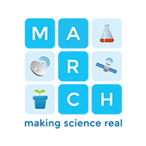

English

To help the students understand the importance of English, they need to see how they can take what they are learning and apply it to the outside world. This can be done various ways. Students can read, write, and give a speech about a certain topic to the class as well as online. They can write and post online. Their post can be critiqued, commented on by their peers. The students can also take anything they write about and make a audio or video recording and post it online.

Foreign Language

How can I always be real?

The most frequent complaint among students when it comes to students teaching Language to them is that is lacks “real” relevance to them. Students do not want to learn languages for literature and grammar purposes. They want to use it in such a way that they can communicate with their peers. They participate in real dialogue on their own in a daily basis through texting, Skyping, and YouTube videos. So as an educator our job is to make language learning about “real communication” not language learning. How can we make it real: Use virtual traveling and spend time in the future to connect in the foreign language around their real lives and passions.

The Future

Spending time in the future is something that schools do not spend enough time on. When partnering with students, we should be encouraging students to think long-term, reflect and find the answers to questions:

- How long until we run out of coal?
- How many songs will eventually fit on an ipad?
- When and how will artificial intelligence equal the brain?

All the while considering the answers to short-term questions:

- What infrastructure should we build in communities?
- How should we be using our resources?
- How should schools and institutions deal with budget cuts or windfall monies?

Other suggestions to making things more real inside the classroom:

- Encourage student learning connections
- Find Groups of Passions
- Connect Student with Peers

More Ways to Make Things Real

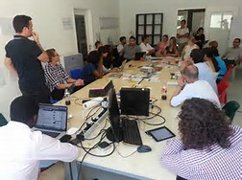
There are numerous ways to make connections to the lives and passions of 21st Century students:

Step 1 - The teacher must recognize that they are not alone. There are connections available online and directly through the students. The more your student partners are equipped with technological research tools the more they can be asked to find, as an essential part of their work, more and deeper connections between the real world and anything they are studying.

Step 2 - Group students for certain work according to their passions and interests. The ability to group students in this way flows from the initial class or classes when you asked what each student's passions are. Grouping students based on their passions is something that is rarely done but it is more interesting for students to be grouped in this way. Grouping students by their passions can also serve as an incentive for students who have not found their passion.

Step 3 - Connecting students through the use of their peers is an excellent learning opportunity but it is rarely done today due to our testing system. It's in our best interest to allow peer connection because that is how the "Adult World" works. Adults work together, ask each other, look things up , and learn from colleagues on the job. Learning through peers also helps in explaining content. Students have the opportunity to hear what others think and whether they share the same interests and perspectives.

Step 4 - Connecting students with practitioners and models in the real world is very important because it becomes easier and easier to do it virtually, using technology. Experts can connect with a class or with individual via texting, Skype, prerecorded presentations, blog posts, Facebook messages, and many other ways, with new ones continuing to evolve.

Always Think Future
One of the most important and useful things about a true pedagogy is that the teacher, in the role of each coach and mentor, is always thinking about th world that students will be going out into, and preparing them for the world. In the past things didn't change drastically; but in the future things will change rapidly. While this may or may not be a good thing, the past is to always be respected even though our students will not live in it. While partnering teachers prepare students for their exams, they also prepare them for their future, when little if any of the subject matter on the tests will matter. Partnering teachers will hep students graduate and go to college, they also will help them find their passion so that they will know what they want to do in, and after, college. Partnering teachers are also preparing them for tomorrow's world, in which most information is written. These are big, new jobs for teachers. Through partnering, these jobs will be accomplished.

Chapter 5

PLANNING

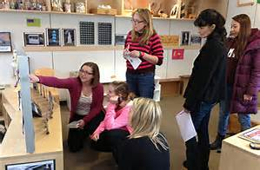

One of the greatest benefits of partnering is that it frees the teacher from the tedious task of planning by preparing lectures. But what exactly does planning consist of in the partnering pedagogy strategy?

- The important component, translating. Translating the content of the lessons into the questions will require the teacher to guide students to the information and learning they need, without the teacher having to tell them.
- Next, partnering planning. In this step, the teacher must figure out how to make an explicit connection to the underlying skills, or verbs, that the students are learning and practicing as they answer the guiding questions and learn the content of the lesson.

CREATING GUDING QUESTIONS

Questions are the device that frames, guides, and ultimately evaluates all learning. Partnering pedagogy is composed of all students asking questions before, rather than after. They are answered by the content of lessons. In doing so, it is important to ensure that all students understand beforehand.

Guiding questions are the primary way teachers translate the curriculum they are required to teach into their partnering pedagogy. Teachers must be able to answer the key questions that you are focusing on that day.

Guiding questions come in 2 varieties:
- Big or overarching questions more commonly known as goals or objectives of the lesson.

2. More detailed incremental or supporting questions.

Partnering Tip: When planning, always think about what you can ask students, rather than what you can tell them.

A good way to think of guiding questions is to think of what you or others might ask your students in order to check their understanding of the material you are teaching. Keep questions at a minimum of 5 to 10 of the most important.

Bad, Good, and Better Guiding Questions:

Bad:

- can be answered simply, with a right answer
- do not have multiple solutions and subquestions for students to explore
- do not fit in the time frame available (too broad or too narrow)

Good:

- have multiple solutions and no simple answer
- have local and global implications
- have practical results

Better:

- students react by saying, "That's a good question"
- they can be adapted to different student interests and passions
- they lead students to real actions that change the world.

A great advantage of giving students the questions, rather than the answers, is that each student or group can approach finding the answers in his or her own way. All that matters is that the answers be right and that the students learn them. In the partnering pedagogy, the teacher need only hand out or post the day's questions and then act as a coach and hide as students use the resources at their disposal to answer questions. Students choose whether to work individually or in groups. Remember to make short presentations and/or the teacher leads a discussion to verify whether the questions have been answered correctly and the material learned. Note: think of variations on this basic approach.

A key job for teachers is to help each student relate the guiding questions to his or her own, individual passions. Like many lessons, be pitched to different students or groups in terms of music, sports, computers, science, art, and many other student passions as well.

1. Plan for Student 1: given what I know about his or her passions and progress.

2. Plan for Student 2: given what I know about his or her passions and progress.

3. Plan for Student 3: given what I know about his or her passions and progress.

Doing this everyday may not be realistic or even possible. But you can allow students to co-plan along with you and ensure that they are aware of their responsibility to link what is discussed to their own passion.

Students/Groups get to choose their own path to answering the guiding questions and teachers must plan for this. Teachers can expect a nosier and looser classroom environment compared to those of a traditional setting. The teacher will more than likely be found walking around the classroom giving student advice, guidance, and offering suggestions on where to look and find answers. Partnering definitely does not meant hat your classroom should devolve into chaos. Creating a shared understanding with your students that they are being given responsibility for their own learning.

3 Rules of the Classroom:

1. Always try to behave critically

2. Do your best to learn

3. Don't disturb anyone else in the process.

FOCUS ON THE VERBS

The second most important connection between the partnering pedagogy and the curriculum,used in planning, comes through verbs, or skills, that are connected to and appropriate for answering the guiding questions. The verbs are the skills that are mandated in the curriculum and that students learn through their partnering work.

Note: It's important that students understand that it is skills they are learning, not just facts and content.

Just as students need to always know what questions they are answering, they also need to know, at every moment, precisely what skills they are being asked to learn, practice, and master as they answer those questions. Computer and video games are an excellent example in doing this by helping the players understand this concept. Partnering teachers should do something similar. Articulate the skills being learned and help students understand how good they are at each skill.

Partnering Tip: Try to hold discussions in a completely Socratic mode, with you and the students asking questions that get people to reflect on their own positions.

Chapter 6

NOUNS: THE TOOLS STUDENTS USE
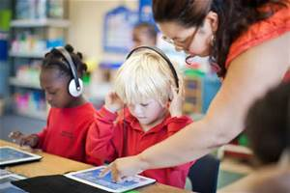

Like wise in partnering pedagogy of planning, the use of technology in partnering requires nouns. The actual technology tools used by students to answer the guiding questions, practice the over-and underlying skills,make presentations, and simultaneously learn the material. Nouns are tools for "doing" the verbs. And unlike the verbs, nouns change. They change with the times and along with improvements in technology. Types of tools that can be used are discussed in chapter 7.

TECHNOLOGY

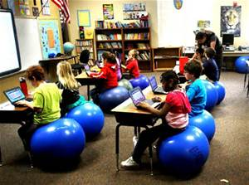
Once the partnering teacher has given the guiding questions to students and made certain that students understand the appropriate verbs, the teacher's job is to let them work, on their own and with peers, until they have convinced themselves and the teacher that they know the answers to the questions and have mastered the required skills.

Note: For students to learn on their own they need tools. Teacher's need to be aware of these tools and make them available to students.

Not all technology will be available to everyone; but that is OK. In th long run, all students should have the opportunity to access a bare minimum of technology tools. 1:1 Computing is on the rise in today's classrooms and if they are not yet apart of the classroom, be on the lookout. Partnering teachers need to be proactive in their findings of what technology is available in schools today; and ensure that use is readily accessible to ALL students.

The next step requires partnering teachers to understand how these technologies can aid in student learning. Sit back and let the students have at it. Most teachers who are successful in partnering technology are the those who say " I never touch the stuff. I sit back and let my students do it all." The Prensky Apostasy states: "It is the student's job, not the teacher's."

What exactly is the teacher's role with regard to technology:

1. Point out to students all technologies that are available.

2. Carefully watch as students use technologies and present them.

3. Encourage, or even require, students to make use of many different technologies as possible over the course of a year.

4. Point out potential pitfalls and mistakes that are often made by students when using technology, and help them to become better at using those tools.

There are 4 Special cases: Web 2.0, 1:1 - The Coming Wave, Cellphones, and Games

Web 2.0 is where we are now. Web 2.0 is a medium for reading, watching, and publishing. Web 2.0 is only a shock to those who iternalized the model of the Web as a library. In addition to Web 2.0, Web 3.0 is a "semantic web" that is up and coming that will allow users to search any work ever created for anything and link any pieces together.

A partnering teacher whose students have their own laptops in class has an obligation to ensure that they are used regularly as apart of the student's required work. If 1:1 computers become apart of your classroom, begin work with them by holding conversation with the class about how to use them. Discuss responsibilities and how the computers can be best used.

Cell Phones are a technology that merits a discussion of it's own, if only because so many educators are so confused about what to do with them. Should they be banned? Should students be allowed to use them in the classroom? The best method to use towards finding the answer: hold a discussion with students about whether and how cell phones should be used for learning. If all students do not have cell phones, then consider this issues to be a "glass half full" situation. Half of the students don't have a cell phone, then cell phones can not be used.

Many teachers use games already and all partnering teachers are encouraged to do so. The best way to manage games inside the classroom is to ask your students if any of them have played a game that relates to what they are learning. If yes, present it to the class and integrate learning in that approach.

No technology available?
If technology is not available for students to use, teachers can tell students to assume they have it. While assuming the students can brainstorm about how they would use it.

Using appropriate nouns for guided questions and verbs
It is important to find appropriate tools, or nouns, for the students to use to answer the guided question and practice the verbs. As questions and verbs change so should the tools.

Chapter 7

Understanding the Nouns or Tools

Teaching digital Natives contains over 130 types of tools.

Important: Tools are list alphabetically, not in order of importance.

Nouns change rapidly and the list needs updating, often.

The list is selective and doesn’t include every tool, or even every type of tool available.

(cf) refers to another entry in this list.

To find more information and examples for any listing, search for the term in Wikipedia.

Partnering Tip: Share this list of tools with your students. Discuss the list to both learn more about tools and to which tools your students are interested in using.

Below are descriptions of a few tools one can use in the classroom.

3D Printers

- 3D printers are machines that take the output of a design that a person has created using a computer-aided design or other program and , by both adding and sculpting material to create a complex 3D object. The object can be held painted modified and used to get a feel for the final, manufactures object.

- Verbs supported by these tools: exploring, experimenting, modeling, designing, innovating, tinkering, making, presenting.

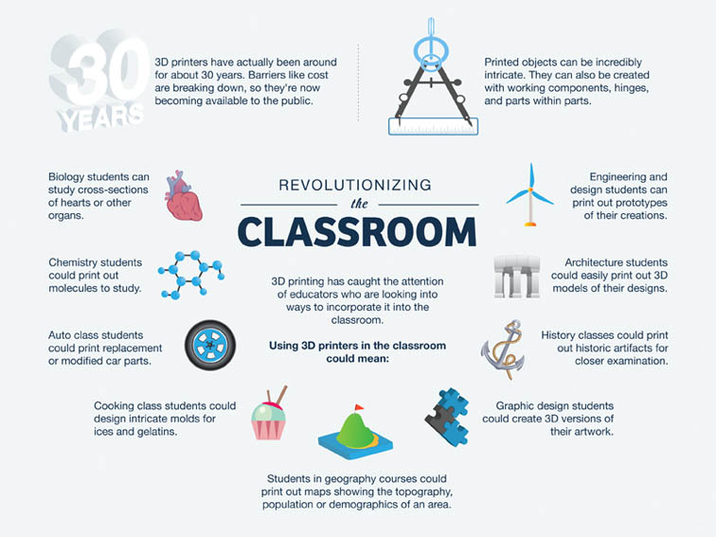

- Classroom lesson plans using 3D printers

Animation Tools

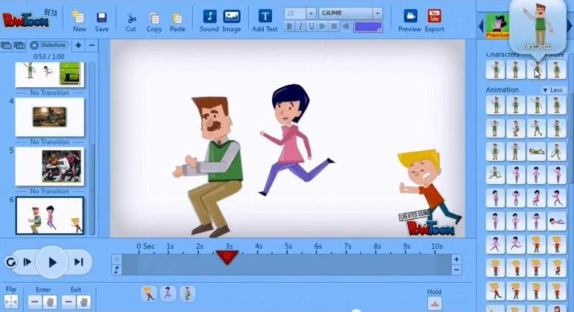

- These tools allow students to create their own animations on any topic

- Verbs supported by these tools: writing, creating, designing, and making.

- List of animation tool resources

Artificial Intelligence tools

- These programs try to make a computer approximate what a human might do. Students can use these tools to try to understand and mimic human behaviors.

- Verbs supported by these tools: analyzing, deciding, predicting, planning, programming.

- Benefits of artificial intelligence in the classroom.

Blogs and Blogging Tools

></div>
- A blog is a website where people express their thoughts and/or experiences. Students can use blogs to record many things such as what they learned in school.

- Verbs supported by these tools: reflecting, thinking, logically. collaborating, writing, thinking creatively.

- Different Blog Sites

Comic Creation Tools

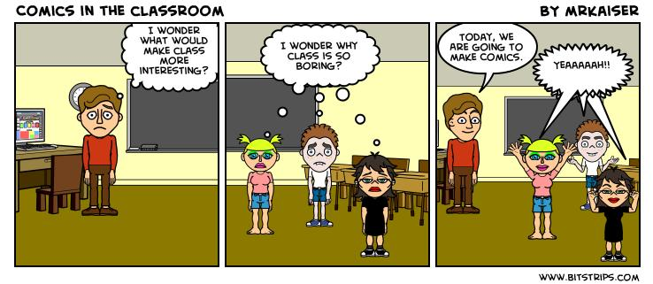

- This type of tools is a software that enables students to create and tell stories in the multiple panel style of comic books. These tools can be used by foreign language learners too.

- Verbs supported by these tools: writing, creating, designing, and making.

- Tools for making comics

Interactive White Boards

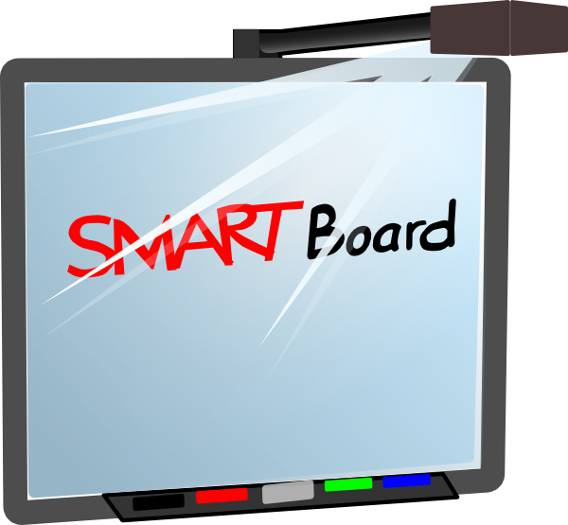

- Large surfaces where one can write, display images from the internet, and use and display a number of interactive programs.

- Verbs supported by these tools: used thoughtfully, this tool can support almost any verb.

- Ways to incorporate interactive white boards in the classroom.

Virtual Labs
- These tools allow students to compete the same functions and experiments that can be done in the lab using physical materials on the computer.

- Verbs supported by these tools: analyzing, exploring, finding, verifying, calculating, comparing, deciding, evaluating,experimenting, obseving, predicting, questioning, thinking logically, cooperating, innovating, prudent risk taking.

Teaching and learning science with virtual labs

Chapter 8

Let Your Students Create

Today's students want to create but are not given enough opportunities to do so. Knowing all the tools listed in chapter 7 it makes since that todays students want to create things that are more challenging than projects in the past. It is the teacher's role in partnering to give students the opportunity to create and support them as they are doing so. The teacher may not know how to use all the tools the students use, and that's OK. What matters is that the teacher allows them to create at the maximum level of which they are capable, and that the teacher accepts that the objective, or assignment, might be accomplished in different ways.
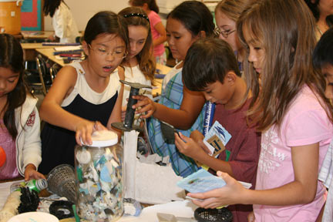
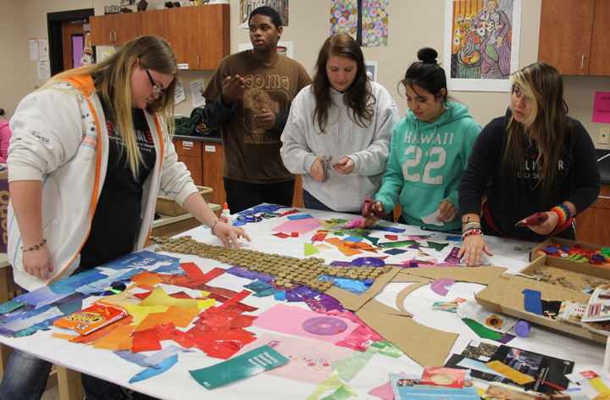

A Real, World Audience

In the past students presented their creation to just the teacher and maybe the class. Today's students can present their work to a world audience. The world can give feedback to the students creation. This allows students to see where they stand not just in should but in the real world. Example of presenting to a real world audience. This is just another activity that goes along with the idea "making it real" discussed in chapter 4.

"Having a real audience is, many teachers report, an incentive for students to do better work."

World Conversations

There are "world conversations" going on all the time in various forms. Partnering teachers should encourage the students to seek out and join these conversations, contributing whatever, wherever, and whenever their passions lead them.

Aim High, Raise The Bar

Today's educators underestimate the students capability of creating. When students do come up with works of high quality, educators are surprised by the students' accomplishments. Instead of having setting the bar low, we need to raise that bar and challenge our students to reach it. When evaluating the academic performances of students it is important to not just let their technology capabilities be how they impress us. We need to focus on the quality of the content presented. The students like being challenged and being able to have the freedom to create in their own way.

Allow Choice

Giving students options inspires them to do assignments. When they have the option to create in a way that is interesting to them they are more likely to participate. For example: Allowing the students to choose how to complete reading assignments may engage the students. Giving children the option to choose his or her own work to analyze and tell us where and how it contains the elements we are looking for can be a more engaging way for students to learn the same goals. It is important for the students likes and desires be heard and balancing those wants with the requirements. We still need to open kids minds to new things and experiences, in the hope they will grow to appreciate them as we do. It is also important to remember that the students can influence the educators just like the educators influence the students.

Engage Slackers

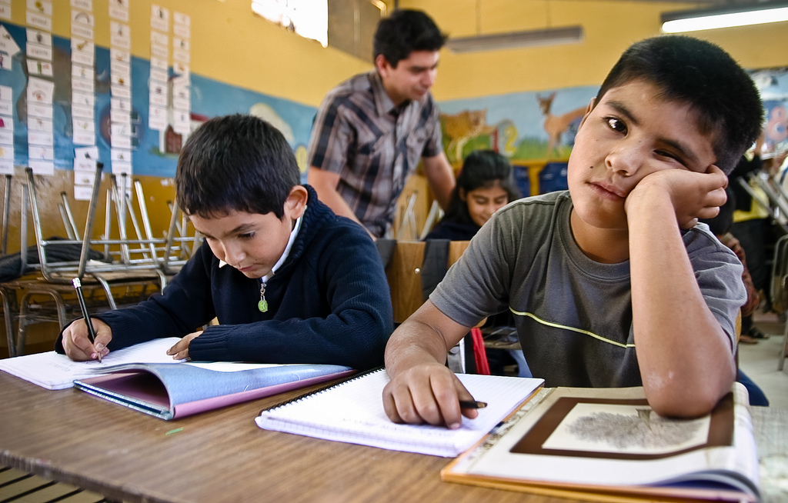

What about those students who slack off or tune-out or the ones who never seen interested? How can we engage them? Most of the time the students are just not interested in the learning styles the teachers offer. They don't mind learning or doing work, they just want to do it in a way that interest them. Allowing students to follow their own interests can be just the motivation they need to participate in the class. Another thing to do is to emphasize the importance of quality over quantity. Combining the idea of meeting their own interest and doing "less" work may motivate those "slackers" to do their work. It is the teachers' job to help connect the work to the students' passions.

Bring In The Pros

Bringing in professionals to teach kids about certain content areas is a great way to engage the students. If you can't physically bring in professionals, their are numerous resources for finding professional videos online. Students tend to like having professionals be the one to explain curtain topics.

Ask Students for Technologies to Use

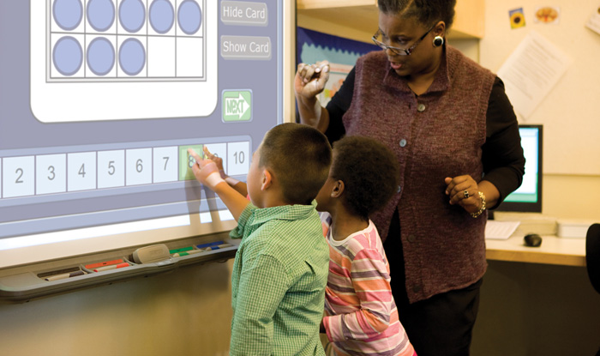

It is important to include the students when coming up with ways to present material. Teachers can ask the students for their thoughts on what tools to use. They may even learn about new tools from their students.

Partnering Tip: As you find out more about your student's passions, also find out what they like to create and have created in the past. Make and post a list of possible creations, that students can choose from or add to. Encourage students to try their their hand at all of these over the course of the semester or year. To help students who are unfamiliar with some of the tools learn, create teams combining experienced people with newbies.

Chapter 9

"There are very few principles more important to learning and doing anything than continuous improvement." (Prensky 159)

Nobody begins something and is perfect at it. It takes devotion and hard work to continuously improve and get better. This concept is the same in partnering. It requires multiple skills such as: coaching, guiding, goal setting, questioning, and designing. Teachers are not the only ones that need continuous improvement in partnering, but students as well. Most students have gone through their education being taught the traditional ways of being filled with information, then being told to repeat it. It takes a different form of thinking to learn on your own with the teacher as the guide or coach on the sidelines.This form of learning expects students to be able to take the lead, taking the initiative, answering the guided questions thoroughly, practicing and mastering skills, and using all the resources available to their fullest potential.

Three main routes to continuous improvement:

1. Iteration
2. Practice
3. Sharing

Improving Through Iteration

"Practice makes perfect" only applies if the right things are being practiced. The best way to find the right things is through iteration. Teachers and students should iterate, removing things that don't work, trying new things, handling the ups and downs, review and discuss what happens, and work continuously to improve. A great way to do this is through journals or blogs.

Iteration and Variety

21st century students crave variety and change. The more things teachers try, the more students become interested. Since technology is constatnly changing, each year is full of new options. The best time to start with iteration is at the beginning of the year. No matter what the students from the years prior have taught you, adjustments will always need to be made.

Iterating Student's Work

Teachers should encourage students to see all of their work as a series of continuous improvements to their skills. Students should be asked to adjust work that they have done, to iterate it and make it better than before. By doing this throughout the year, students will begin to see their work improving.

Improving Through Practice

Once the partnering has begun and you have iterated as much as possible - the more you practice, the better you get.

Practice for Students

1. Self-motivation and self-discipline are two things that are required for successful partnering. This does not come automatically or immediately for all students, but each student is able to get better at each of these skills. Teachers should encourage and help students to achieve a level of success.

2. Students need to practice the required verbs.

3. Students need to practice making connections between their own passions and interests and the work that they are doing in the classroom. This connection is a very important motivator for students to succeed.

Students will always do better at something they are more passionate about. In partnering, as long as the student achieves the goal, it doesn't matter how they got there. Each student learns differently and are encouraged to choose their own path to discover the answer to the guided questions. This takes practice, just like the topics before. Students need to practice in order to find their own way of learning.

Some students will prefer the traditional way of learning. Discovering these student's passions is the key to getting them motivated. Learning the partnered pedagogy will last students a lifetime. It carries on into their future where it becomes about more than just test scores.

Practice for Teachers

Teachers need to practice in order to let go of the notion that they need to be on the stage with students working on their own.

"At the outset the teachers were very concerned about how the process would unfold. They were apprehensive about giving up control and worried that the students would not pick up the reins and do the work. By the end of the project however those concerns had virtually dropped."

Practicing the Roles - Taking Motivating Strategies From Video Games
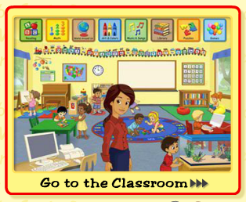

The roles that video games play in the learning process are greater than one might realize. Teachers can learn a lot from the games that students play. Video game creators design games to appeal to a very broad range of people. These games make each person that plays then feel differently. The player is made to feel that the game is customized to their personal preferences, abilities, and needs. This is the same thing that teachers are trying to do with the curriculum in the classroom. Another thing that video games do is set up clear goals. These goals are able to be reached through many different paths. The feedback from the paths chosen is immediate, frequent, and assists the player in reaching the goal. This is yet another goal of teachers in partnering, to show students that they can reach their goal through whatever way they feel is easiest for them. Using computer games to learn can be motivational to 21st century students.

Improving Through Sharing

- Always look for good examples from others.
- Be generous and share your own ideas.

There is a lot of great partnering ideas and exercises going on, but not a lot of it is being shared. This is unhelpful for teachers that are looking to begin partnering in the classroom. The older, predigital generation was taught not to share: "knowledge is power; keep it close to the vest". Today's generation has learned that sharing information is how you gain knowledge and in turn power. Sharing can be done easily through numerous online sources: Twitter, Facebook, Youtube, texting, blogging, etc.

The best ways to share:

- Short Videos - Record videos on cell phones, tablets, laptops, or video recorders, upload them to Youtube, TeacherTube, SchoolTube, or any equivalent.
- Learning from Colleagues - work together with other teachers in the same school, district, around the state, or even other countries around the world.
- As a normal part of the job - instead of traveling several miles for expensive professional conferences, look next door or around the district.

Becoming an Expert "Partnerer": Getting to Level 5
In order to judge how you and your students are doing moving along from the traditional ways of teaching to the new partnering pedagogy is
important to have a metric or rubric.

There are six levels of Partnering for teachers and for students:

Teachers

Level 0: All teaching is done by lecturing and all student practice is done using worksheets.

Level 1: In addition to lectures, other presentation modes, such as DVDs or videos, are introduced periodically. Worksheets are still the primary mode of in-class practice for students.

Level 2: The teacher lectures while using interactive whiteboards and showing PowerPoint presentations and videos. In addition to worksheets, some computer and search-based student activities are introduced in class or in computer labs.

Level 3: The teacher tries to keep lectures short, using a rule of no more minutes per lecture than the grade level. students do a variety of in-class activities, many on the computer.

Level 4: Partnering is done on some days, with some topics. Lectures, explanatioins, and worksheets are still used for some material.

Level 5: All teaching is done through partnering. The teacher never tells or lectures, even when giving instructions. Students always work on their own or in groups, always have clear gals that they know where to find, and accomplish the goals regularly using a variety of tools. Discussions and critiques are student led, fully participative, and lively.

Students

Level 0: Students are expected to listen, take notes, hand in assignments and homework on time, and pass frequent tests.

Level 1: Students engage in some active doing non listening - only activities in addition to those from level 0.

Level 2: Students spend at least half their time doing partnering activities, finding their guiding questions and goals on their own, and selecting activities from a teacher-provided menu.

Level 3: In addition to the activities from Level 2, students discuss upcoming lessons with the teacher, help create guiding questions, suggest activities and tools, and do their own research. There is still some listening and note taking.

Level 4: Students are expected to, and do, find or create guiding questions, do research, make presentations, self-form into groups when necessary, complete self-designed projects, and lead and participate in critiques and discussions.

Level 5: Students do everything from Level 4 and also help the teacher design classes for maximum engagement and teach their peers whenever necessary.

Teaching, especially partnering pedagogy, is not something that can be mastered in one year. It takes time, practice, and learning from mistakes. A partnering teacher is continuously improving with each class and year.

Ways that teachers can help themselves improve are:

1. Let yourself be surprised
2. Set goals for yourself
3. Get feedback from students and colleagues
4. Strive to eliminate boredom

Chapter 10

Useful Assessment: Beyond Just Summative and Formative

Ipsative Assessment: Beating your personal best

Peer Assessment: Have classmates assess the work of their peers.

Real-World Assessment: This extends the peer assessment to peers around the world. Students in different cities and countries can give feedback through online work.

Self-Assessment: Students assess their own performances and critic themselves

"Many teachers have found that just knowing they are writing or creating for a real audience motivates students to increase the quality of their work." (Prensky 178)

Assessing Students with Their Tools

21st century students are surrounded by technology, so it makes sense to include technology in the assessment process. Educators have learned that by allowing students to use technology such as calculators, has increased the students understanding the how and why of the learning process. Many teachers are already allowing open-book tests, so why not incorporate "open-phone" tests. Students will have to use appropriate and reliable research tools and sources to search for their answer, rather than just memorization.

Partnering Tip: Think about situations in which evaluating students with their tools might be a good idea. Ask your students about this. Are they in favor of it? How would they deal with the various issues that might arise?What do you and your students think of open-phone tests? Try creating and using these options and discuss the results with your students, and then iterate to make it more effective.

Assessing Students' Progress

- give students necessary and helpful feedback (formative)
- encourage them to do better and better (ipsative)
- provide them with feedback form fellow students (peer)
- include evaluations from a global audience (real-world)
- get them to understand their own progress
- allow them to use their tools (21st centruy)
- because we have to, satisfy the outside world by using standardized tests (summative

Addressing Assessment Fears

The biggest fear expressed by teachers, administrators, and parents is that students in partnering pedagogy will not do well on standardized tests. Another fear is that this form of learning will not count, because they are not being tested frequently. In reality students in partnering pedagogy do very well on tests, because of their deep understanding of the content due to their high levels of engagement throughout the process.
Assessing Teacher's Progress

Assessing their own skills goes beyond reviewing their progress. This assessment should be shared with administrators, parents, colleagues, and even the students. "Across the rainbow" is one way of visualizing this progress. Each level of partnering has a color with the teacher aiming for the "unattainable violet". This can be displayed for others to see, which works as a motivator as well. This progress is not about being a "good" teacher, but rather encompassing the qualities needed to be successful at partnering: empathy for students, knowledge of the subject area, enthusiasm for the subject area, staying up to date on one's subject area, and staying motivated to continue to improve at all of these qualities.

Assessing Administrators' Progress

- Do administrators believe partnering is the way to go?
- Is there consensus? If not, where is the discord?
- Do administrators know where each of their teachers stands on the partnering continuum?
- In what ways do administrators support partnering?
- In what ways do administrators support teachers who are looking to partner more?
- In what ways do administrators hep recalcitrant teachers change?
- In what ways do administrators support partnering students and their parents?
Assessing Parents' Progress

"Parents, as everyone knows, are crucial to their kids' education. It is up to the teacher to help the parents see how the world is changing, how this affects their students' education, and understand how the needs of the future should be met. 21st century students require a different style of learning compared to traditional methods.

Prensky lists the following recommendations to partnering teachers:

- Involve your students' parents as much as you can. Open house is a great way to involve parents.
- Use as much technology as you can to communicate with parents.
- Share parts of Prensky's book.
- Encourage students to share their positive classroom experiences.
- Invite parents to come into your classroom and to participate on student teams.

A Checklist for Parents of Partnering Students

- Listening to their children
- Helping their children
- Encouraging their children
- Participating in parent-teacher meetings and other parent events
- Sharing their knowledge by coming to school and talking with students

Assessing School's Progress

You will begin to see the following results:
- Rising test scores - students who participate in partnering will be happier with what they are doing, more engaged in the learning process, learning is clearer through guided questions, skills are practiced more with their peers, on their own, and therefore lead to them being more effective learners.
- More quality student work for them to post and be proud of.
- Teachers sharing successes and working together more than in traditional settings.
- Better student-teacher relationships.

Assessing our nation's progress and the world's

It has been said that America is "falling behind" to other countries in education. The data being measured is dependant on rankings on comparative tests and graduation rates in U.S. high school and colleges. These measurements do not tell all that is really going on and do not give proper solutions to correct the problem. Do we want a future generation that is great at taking tests, or one that is great at solving problems, knowing how to get the job done creatively, and can get it done while working with others? Do we want a future generation that has a high reading level and at a minimum an associates degree or one that can tackle the ever changing digital world in which we live and make such machines function properly.

Are we really falling behind? Most of the recent Internet inventions lately have come from the U.S. In some areas, such as traditional school subjects the United states is behind, but obviously ahead in other areas such as technology advancements. The things that are being taught in todays schools might not be what students are needing for future success. Also, why not measure the world as a whole, instead of nation by nation. The area of education is one that we should all be collaborating together on to raise the standards, not just for the United States, but for all children all over the world.

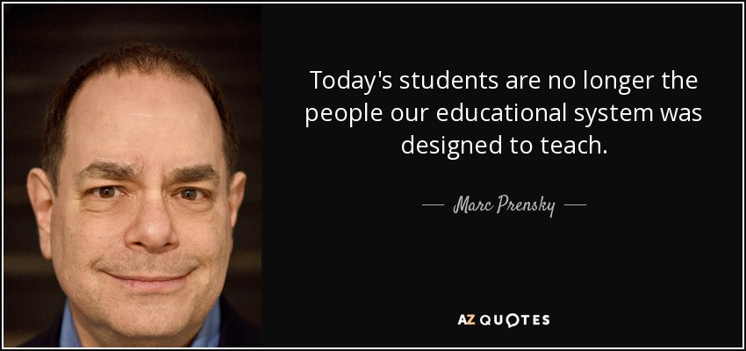

Conclusion

There is a new realization for those over the age of 25 to consider: The younger generation has a very real and equal contribution to make. There are two issues that need to be addressed.

1. What our students need to learn for the future is, to an enormous degree, different than what we are teaching now.
2. Future education is a worldwide issue, not just a state or national one.

Using The Partnering Pedagogy With The New Curricula

The first step in changing the curriculum is to incorporate new skills, such as particularly technology fluency and multimedia literacy, into the curriculum taught today. However, there is too much to teach already so how do we add more? In order to have students learn important skills they need to succeed in todays world we need to eliminate portions of todays curriculum that is less beneficial. Because there are so many tools and resources for students to use, some of the things people use to have to remember the students today have access to them through technology. We need to teach the students how to properly use these resources instead of teaching "backup" curriculum. Education needs to have more of a focus on verbs than on nouns while at the same time knowing the nouns will continually change.

Creating Schools With Partnering In Mind

As the younger population grows, people are thinking about building and creating new schools. What are some things people should think about when building these new schools, particularly with partnering pedagogy in mind. Some wonder if school buildings are even necessary for the future.

Do We Need Classrooms?

Lets say that school buildings are necessary, are classrooms? Traditional classrooms have a fixed layout limiting classroom design flexibility. With partnering it is beneficial to have a layout that is more flexible. How can we create a more flexible layout while still having the privacy students and teachers need to work? One way to create this type of layout is by having flexible soundproof partitions allowing most spaces to be reconfigured radically, typically under 10 minutes. When designing these layouts it would be a good idea for students to have a say in what they wish to have. The school staff and students work together to design a space.

TOWARD A 21st Century EDUCATION FOR ALL

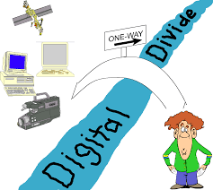

Education today is still very unequal. Half the people under the age of 25 still don't have access to most educational means. One of the great opportunities that technology brings is that it has the potential to bridge this gap together. For more information on bringing everyone around the world up to 21st Century speed, please see "The Digital Divide".

